Project Activity Report-4

Project Title: “Build a GNU/Linux Distribution”

Team members: Faculty Guide:

Arpan Chavda (09bce006) Dr. Sanjay Garg

Hitesh Piprotar (09bce054) Computer Sci. & Engg. Department



Duration: 1/3/2013 to 15/3/2013

* This time, we are focusing on the development of English to Gujarati Dictionary that will be provided in OpenGujarat GNU/Linux Operating system.
* The main objective behind this application development is to enhance the productivity and more functionality in OpenGujarat OS.

**DICTIONARY**

* This dictionary is general dictionary that will provide meaning of given English words into gujarati meaning.
* Dictionary is going to develop for OpenGujarat as well as this dictionary can be ported or installed in other system.

**CURRENT STATUS**

* There is no dictionary (English to Gujarati) available for any linux(debian or RPM package management system) operating system till now.
* This is our first time development in this space.

**PORTING SYSTEM**

* We will try to port this dictionary on linux and android platform in short time.
* We have short time so we will try to use other third party application to port our dictionary in desired system.

**Dictionary Front End**

* Dictionary front end means Dicitonary look up program. The application that gives interface between database and user to manipulate information in easy way.
* LINUX :
  + FRONT END:
    - STAR DICT (APPLICATION) or GOLDEN DICT(APPLICATION):
      * This front end application is available on Ubuntu repository. You can install via following commands.

sudo apt-get install stardict

sudo apt-get install goldendict

* ANDROID:
  + FRONT END:
    - Golden Dict(Application):
      * This front end application can be downloaded from Google play store.([Link](https://play.google.com/store/apps/details?id=mobi.goldendict.android.free&hl=en))

**Dictionary back end**

* Dictionary back end means the database that includes English words and meaning of that words in Gujarati.
* Database is provided by [GujaratiLexicon.com](http://gujaratilexicon.com).
* This database contains around 52,000 words.

**Dictionary Screenshot**

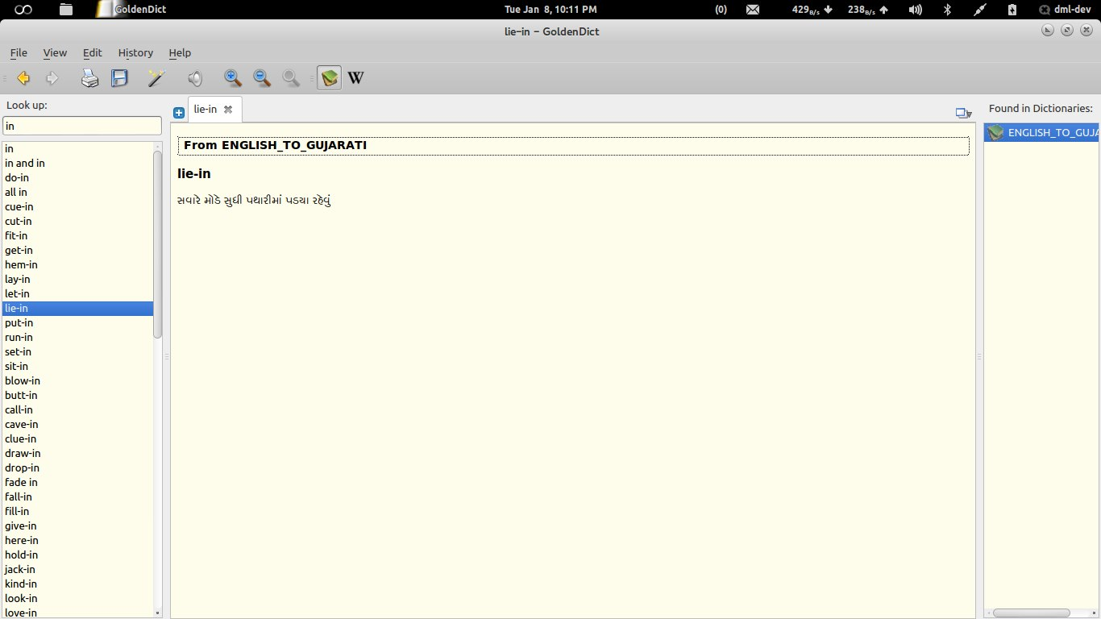

Figure : Dictionary in Linux

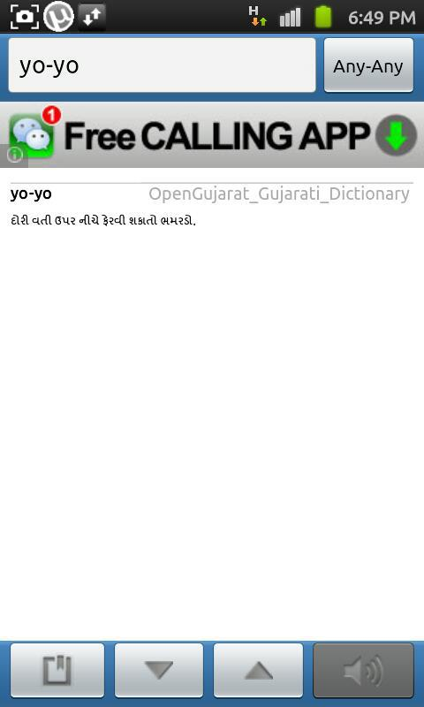

Figure : Dictionary in Android(2.3.6)

**References**

* Project Hosted at <https://github.com/codejar-lab/oguj-dict-pkg>
* Goldendict(<http://goldendict.org>)